Occurrence records for ecological niche modeling:



* GBIF (<https://www.gbif.org/en/> ): global database that comprises many of the following

[](https://www.google.com/url?sa=i&rct=j&q=&esrc=s&source=images&cd=&ved=2ahUKEwjYmZvr3-TjAhUKRKwKHaTNBNsQjRx6BAgBEAU&url=https%3A%2F%2Fholos.berkeley.edu%2Fabout%2Fdata-discovery%2Fvertnet%2F&psig=AOvVaw3M5Efuanq264MIt0qyq4xZ&ust=1564854606267702)

* VertNet (<http://vertnet.org/>): vertebrates (mammals, reptiles, amphibians, birds, fish):



* SCAN (<https://scan-bugs.org/portal/Invertebrates/> ): invertebrates (insects, arachnids):

[](https://www.google.com/url?sa=i&rct=j&q=&esrc=s&source=images&cd=&ved=2ahUKEwjBp4m_3-TjAhVCX60KHdELBfEQjRx6BAgBEAU&url=https%3A%2F%2Finaturalist.nz%2Fpages%2Fmobile_apps_nz&psig=AOvVaw0upYTngI1R2ANQGAgZLJMo&ust=1564854515053071)

* iNaturalist (<https://www.inaturalist.org/> ): literally everything

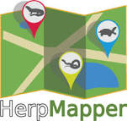

* HerpMapper (<https://www.herpmapper.org/> ): reptiles and amphibians
* [](http://www.naherp.com/)NAHerp (<http://www.naherp.com/> ): reptiles and amphibians

[Home](https://www.tropicos.org/Home.aspx)

* Tropicos (<https://www.tropicos.org/Home.aspx> ): plants
* eBird (<https://ebird.org/home> ): birds
* <https://www.geo-locate.org/> A platform for georeferencing data from natural history collections based on locality descriptions (i.e. where latitude and longitude are not given). Also gives an estimate of precision.

Ecological Niche Modeling with Maxent:

Maxent Website: <http://biodiversityinformatics.amnh.org/open_source/maxent/>

Maxent tutorial: <http://www.amnh.org/content/download/141371/2285439/file/LinC3_SpeciesDistModeling_Ex.pdf>

[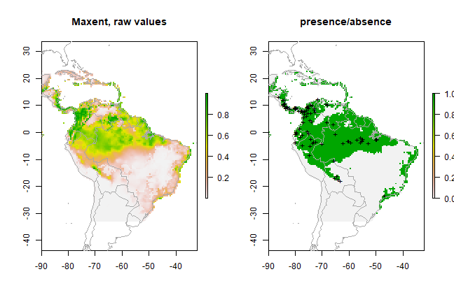](https://www.google.com/url?sa=i&rct=j&q=&esrc=s&source=images&cd=&ved=2ahUKEwjGrMC68uTjAhVKQq0KHaAgAKAQjRx6BAgBEAU&url=https%3A%2F%2Frspatial.org%2Fsdm%2F6_sdm_methods.html&psig=AOvVaw0W7gBaFopia2-ueV2IMUaB&ust=1564859604090615)Maxent Google Groups: <https://groups.google.com/forum/#!forum/MAXENT>

* browse and post questions about Maxent and associated R packages (ENMeval, dismo, ENMtools)

**R packages for niche modeling:**

*ENMeval*: model testing and building ENMs using Maxent

Muscarella R, Galante PJ, Soley‐Guardia M, Boria RA, Kass JM, Uriarte M, Anderson RP. ENM eval: An R package for conducting spatially independent evaluations and estimating optimal model complexity for Maxent ecological niche models. Methods in Ecology and Evolution. 2014 Nov;5(11):1198-205.

**Helpful websites** for getting started with ENMeval:

<https://cran.r-project.org/web/packages/ENMeval/vignettes/ENMeval-vignette.html>

<https://oliveirabrunno.wordpress.com/2016/12/04/compare-the-performance-of-ecological-niche-models-enms/>

*dismo*: builds ENMs using Maxent, can project on different climate scenarios

Hijmans RJ, Phillips S, Leathwick J, Elith J. dismo: Species distribution modeling. R package version 0.8-17. 2013.

**Tutorial:** <https://cran.r-project.org/web/packages/dismo/vignettes/sdm.pdf>

*kuenm*: model testing and building ENMs

Cobos ME, Peterson AT, Barve N, Osorio-Olvera L. kuenm: an R package for detailed development of ecological niche models using Maxent. PeerJ. 2019 Feb 6;7:e6281.

*ENMtools*: various niche assessments, including tests of niche similarity among species

Warren DL, Glor RE, Turelli M. ENMTools: a toolbox for comparative studies of environmental niche models. Ecography. 2010 Jun;33(3):607-11.

**Demonstration**: Dan Warren presents how to build an ENMTools object and species distribution model <https://www.youtube.com/watch?v=fHWujIE-xVY>

*ecospat*

Di Cola V, Broennimann O, Petitpierre B, Breiner FT, D'amen M, Randin C, Engler R, Pottier J, Pio D, Dubuis A, Pellissier L. ecospat: an R package to support spatial analyses and modeling of species niches and distributions. Ecography. 2017 Jun;40(6):774-87.

**Other useful R packages**

*spThin*: thins occurrence records

Aiello‐Lammens ME, Boria RA, Radosavljevic A, Vilela B, Anderson RP. spThin: an R package for spatial thinning of species occurrence records for use in ecological niche models. Ecography. 2015 May;38(5):541-5.

*raster, maptools*: mapping of spatial data

Climate Variables for ecological niche modeling:

**WorldClim** (<https://www.worldclim.org/>): Version 2.0 has ‘current’ (1970-2000) and future climate simulations at a variety of spatial resolutions

**CHELSA** (<https://chelsa-climate.org/>): CHELSA is replacing Worldclim as a source of high-quality, high-resolution climate data: they have LGM, current and future climate layers at a 30-arc-second resolution.

**Paleoclim** (<http://www.paleoclim.org/>): CHELSA data for the present, plus a variety of Pleistocene climate events, at a variety of spatial resolutions

A list of non-climatic environmental predictors is included in an excel sheet, courtesy of Dr. Tereza Jezkova.